Case study of different approaches in Bornholm, Mittskåne Vatten and Kleipeda about handling sludge from septic tanks:

General background

- Bornholms approach: background ….
- Collecting and dewatering sludge
- Composting and use In agriculture
- Energy, nutrients, carbon and economy in this approach

- Mittskåne Vattens approach: Background …
- Collecting and dewatering sludge
- Composting and use In agriculture
- Energy, nutrients, carbon and economy in this approach

- Conclusions about Energy-efficiency, reuse of nutrients and carbon and economy in the different approches

General background / focus of this case study

Many Waste Water Companies also handles the collection, transport, treatment and disposal of sludge from the septic-tanks in the local areas without sewers. There are different approaches to solve the challenges in this work, and the Swedish partner in STEP have focused much of their work to solve their challenges in relation to sludge from septic tanks. In this case study the partners explain their approach in relation to sludge from septic tanks, and we compare the different approaches, in relation to energy-efficiency, reuse of nutrients and carbon, and overall economy.

1. BORNHOLM

Approach and background

In Bornholm the systematic collection and handling of sludge from septic tanks started in 1992, in Nexø municipality. When the five municipalities were merged in 2003, all the app. 5.000 septic tanks on Bornholm was included in systematic collection and handling of sludge. The most common way to handle sludge from septic tanks is to treat it on the larger Waste Water Treatment Plants (WWTP’s).
In Bornholm we have from the start chosen to treat sludge from septic tanks separately, based on concern about capacity and energy consumption of WWTP’s. The sludge from septic tanks is used in agriculture after separate treatment, according to the Danish rules (see study on differences in rules/legislation in the partners countries).

Collecting and dewatering sludge

Bornholms Wastewater A/S, has put the work with sludge form septic tanks out to EU-tender several times, and we have over the years simplified the description of the work to the entrepreneurs (se tender description in appendix 1).
The sludge from emptying septic tanks are collected and dewatered in a special vehicle (KSA – see appendix 2) that manage to empty app. 30-40 before it must be emptied of dewatered sludge
Dewatering is mechanical with use of polymer.
The septic sludge is effectively dewatered to app. 30% Dry Matter (DM)

Composting and use in agriculture

The dewateret sludge is composted in a barn by the farmer that uses the sludge as fertilizer in agriculture. The sludge is mixed with cut straw, and turned regularily. Omce a year, usually in august, the composted sludge is mixed with app. 7% burned lime in, and used as fertilizer in agriculture. Before use we make an analysis of the content of heavy metals and some organic substances specified in the Danish rules – see table 1.

Denmark has the strictest limit value for Cd in EU – 0,8 mg/kg DM – but there are also a limit value in relation to phosphorus – 100 mg/kg P – and it is enough that the content is below one of the limit values. The limit value for Cd in the EU-directive is 20-40 mg/kg DM.

Table 1: Comparison of heavy metals and organics in sludge from septic tanks and WWTP (Rønne)

 | Analysis of composted sludge from septik tanks (mean) | Analysis of sludge from WWTP (Rønne- mean) | Limit values
 | mg/kg DM | mg/kg DM | mg/kg DM
Pb | 26 | 12 | 120
Cd | 1,4 | 0,8 | 0,8
Cu | 258 | 168 | 1.000
Cr | 13 | 10 | 100
Hg | 0,7 | 0,3 | 0,8
Ni | 17 | 10 | 30
Zn | 1.070 | 495 | 4.000
Cd/P (mg/kg P) | 76 | 35 | 100
Hg/P (mg/kg P) | 38 | 14 | 200
Tot N (g/kg DM) | 29,5 | 48,3
Tot P (g/kg DM) | 18,5 | 22,8
LAS | 423 | < 108 | 1.300
sumPAH | 1,7 | 0,6 | 3
sumNPE | 3,4 | 1,5 | 10
DEPH | 2,5 | 5,5 | 50
(More information about the organic compounds is available in the STEP deliverable about National Legislation comparison)

Table 1 shows that the content of heavy metals and organics is generally lowest in the sludge from WWTP. The initial content of organics in the sludge from septic tanks is wery high, and often exceeds the limit values, but composting is effectively reducing these compounds.

In Denmark the rules about use of sludge in agriculture specifies that the producer of sludge must fill out a declaration of the sludge to be used in agriculture, and sens it to the municipality and the farmer.
The declaration tells from where the sludge origins, restrictions in use and storage on the property, and the content of heavy metals and organics.

An examle of such a declaration – see appendix 3

Energy, nutrients, carbon and economy in this approach

Energy consumption – qualitatively assesed
1. Transport: Because the sludge i dewatered in the transport vehicle, the energy use for transportation is app. reduced 50%
2. Dewatering: Dewatering is mechanical with use of polymer, hence the energy consumption is minimal
3. Composting: Low energy consumption – turning the piles – mixing with straw and lime
4. Spreading: Low energy consumption - like other organic fertilizers

Nutrient recycling – qulitatively assesed
1. The composting process involves a small loss of nitrogen – evaporation off ammonium
2. Agriculturea use ensures recucling of all the nutrients in the composted sludge

Carbon storage – qualitatively assesed
1. The composting process involves a small loss of easily degradeble organic carbon (as CO2 emmision)
2. Agriculturea use ensures recycling/storage of all the carbon in the composted sludge, including the added straw

Economy
In 2019 The owners of septic tanks on Bornholm pays:
581 kr. or app. 78 Euro (25% VAT included) for the yearly emptying of a septic tank – all expenses included.
Bornholms Waste Water A/S pays our current contractor:
400 kr. or app. 54 Euro (25% VAT included) per emptied septictank, all included.
Administration of costumer payment, complains etc. and declarations, analysisa of sludge, dialog with autorities etc. is done by the Waste Water Company. This administrative tadks accounts for the differende between costumer payment and contractor payment.

1. HÖÖR AND HÖRBY

Collecting and dewatering sludge - Existing handling
In Sweden, external sludge from septic tanks are collected from individual properties once a year, usually through trucks operated by the municipality. In Höör and Hörby, trucks with the capacity to dewater the sludge on-site is being used. The dewatering on site is achieved by letting the larger particles settle in the tank carried by the truck. The water is then returned to the septic tank on the property. The use of this method means that more septic tanks can be emptied on the same route since the actual volume being emptied is roughly 1 m³ compared to 2-3 m³ if the whole tank would have to be emptied. The truck then transports the sludge to the wastewater treatment plant (WWTP) where it is released into the incoming wastewater stream.

The cost for a truck to empty the content from septic tanks at the wastewater treatment plant is roughly ca 25 €. The cost for MIttskåne Water to ensure a safe collection of the treated sludge is about ca 28 €/ton.

Advantages
Nutrients are recovered and spread on arable land.

Disadvantages
The external sludge usually has a rich content of heavy metals in relation to nutrients and hence deteriorates the sludge quality. Further, the external sludge has relatively low levels of oxygen and therefore needs to be aerated to a larger degree which in turn consumes larger quantities of energy.

External treatment of sludge – Pilot plant

Höör and Hörby wastewater treatment plants have realtively high levels of metals in the processed sludge, this has been a problem for many years. According to internal analyses, the reason for these levels are most likely due to the sludge from the septic tanks (Table 1).

Table 1. Comparison of the mean values for dewatered external sludge to the processed sludge at the wastewater treatment plant (WWTP) in Hörby (mg/kg dry matter).
 | Dewatered external sludge | Processed sludge at the WWTP | Threshold limits
Pb | 10,97 | 8 | 100
Cd | 0,70 | 0,71 | 2
Cu | 624 | 389 | 600
Cr | 9,94 | 19,75 | 100
Hg | 0,32 | 0,22 | 2,5
Ni | 9,75 | 10,56 | 50
Zn | 873 | 469 | 800
Cd/P | 103 | 36

Since the sludge from the septic tanks are responsible for a considerable part of the metal load there are reasons to investigate this issue further. Mittskåne Water therefore took the decision to evaluate a new setup where the external sludge from septic tanks are treated separately. If the sludge is dewatered and the water phase, the supernatant, is the only fraction released into the incoming wastewater stream possibly a reduction in metal load could be obtained. Mittskåne Water has therefore rented and purchased equipment to put this solution into practice.

A dewatering system for external sludge is already being used by the Municipality of Östersund (Figure 1).

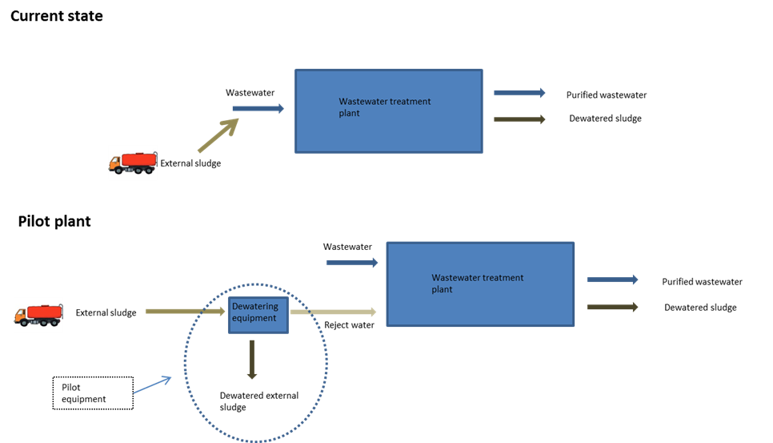
Figure 1. The external handling system for sludge at the Municipality of Östersund.
The facility in Östersund has been operational for several years and it is therefore possible to evaluate the investment.

The facility receives about 6 500 – 7 000 m³/year and is operational for about 7-8 months per year (not during winter). Roughly, it can be considered as two parts: The reciever part and the dewatering part.

The part that recieves the sludge is comprised of a tile drainage layer and integrated screenings press and washing system. The total energy demand can be estimated to 556 kWh/season. Electricity, water and maintenance are not included in the prize.

Table 2. Energy demand of the receiver part.
Filtration 2,2kw x 121h | 265 kwh
Two sand ”traps” (1,1kw x 51h) + (0,55 x 66h) | 91 kwh
Screw wash press 3kw x 66h | 200 kwh
Total | 556 kwh/ season

The dewatering part is comprised of two pumps, one for the sludge and one for the polymers, the dewatering device and transport equipment for the sludge to the silo.

Table 3. Energy demand of the dewatering part.
Pump for polymers 1,1kw x 867h | 950 kWh
Dewatering device, 1,5 kw x 867h | 1300 kWh
Sludge pump, 4kw X 867h | 3468 kWh
Sludge screw transporter (3kw x 867h) x 3st | 7800 kWh
Total | 13500 kWh/season

The need for chemicals and associated costs
External sludge is easily dewatered and a polymer flow of 250 liters/hour with a dry matter ratio of 0,15 – 0,20% with a corresponding sludge flow of 6-7 m³/h have been found to enhance operations. Only one polymer is being used for the dewatering.
The concentration 0,20% returns (in solid form) 0,5 kg powder/ 250 liters complete solution.
867 x 0,5 kg returns a consumption of polymers of roughly 400 kg/season.
Total cost (if the kg price of polymers is about 2,5-3 €) = 1 200 €

In total for the year 2013, a volume of 6600 m³ external sludge was treated. Dry matter level before dewatering was observed to 1% and after 27%. Electricity for the dewatering of 1 m³ sludge amounted to 2,12 kWh/m³. The cost for chemicals (polymers) was estimated to 0,2 €/m³.

Composting and use in agriculture

The table below shows the level of metals and nutrients in the external sludge compared to current legislations. The increased metal levels mean that the sludge cannot be dispersed on arable land. The low nutrient content also signals that the sludge wouldn’t, in any case, be suitable for this purpose. The advantage is, however, that the metal content from the WWTP is reduced since the external sludge has been treated in a different process. The chances that the outgoing sludge from the WWTP will be better suited for dispersal on arable land will be increased.

Table 4. Comparison of legislation thresholds for metal content with the content at Hörby WWTP after the pilot plant evaluation (mg/kg dry matter)
 | Threshold current legislation | Threshold proposed legislation (2030) | Metal content dewatered external sludge (pilot plant)
Pb | 100 | 25 | 11
Cd | 2 | 0,8 | 0,70
Cu | 600 | 475 | 624
Cr | 100 | 35 | 9,94
Hg | 2,5 | 0,6 | 0,32
Ni | 50 | 30 | 9,75
Zn | 800 | 700 | 873
NH₄-N | - | - | 4,7
N-tot | - | - | 32,7
P-tot | - | - | 6,7
TS | - | - | 33
Cd/P-kvot |  |  | 103

Energy, nutrients, carbon and economy in this approach
It is difficult to compare the current handling with an external handling of sludge since there exist very little data and the result will be heavily influenced by site characteristics (Table 5).

Table 5. Summary of the alternatives.
 | Current handling | External handling of sludge
Energy | Amount of energy per cubic meter external sludge that is treated at the WWTP (12,5 kWh/m³ – Danish EPA 1991) | Energy consumption is estimated to 2,12 kWh/m³ external sludge to icnrease the level of dry matter from 1 to 27% (Municipality of Östersund facility). To this it must be added the energy consumption for treatment of the supernatant.
Conclusion | Current handling demands more/less energy than an external handling.
Nutriens | The nutrients are recovered and recirculated by dispersal on arabble land. | Since the dewatered sludge contains high levels of metals it cannot be dispersed on arable land. However, the prerequisites for a dispersal of the sludge carried by sewers to the WWTP are enhanced.
Conclusion | Both manners can increase or decrease the dispersal of sludge on arable land.
Carbon | Spread on arable land. The reactive carbon is mineralized at the WWTP. | The external sludge will most likely be combusted and then the carbon will be transformed to carbondioxide instead of stored in the soil.
Transport | The transports will be reduced since the trucks carrying the sludge returns liquid to the septic tanks. There is also another type of dewatering where polymer is used which generates a higher dry matter level and therefore increased return of liquid which in turn generates a lower demand for transports.
Economy | <deleted from swedish report> | <deleted from swedish report>
Conclusion | Very hard to estimate the cost for treating 1 m³ of external sludge.
User economy | The cost for emptying a septic tank at the treatment plant is roughly 25 € per septic tank. The owner of the septic tank pays about 90 € to have the tank emptied.

