Dewatering of external sludge to decrease levels of heavy metals

**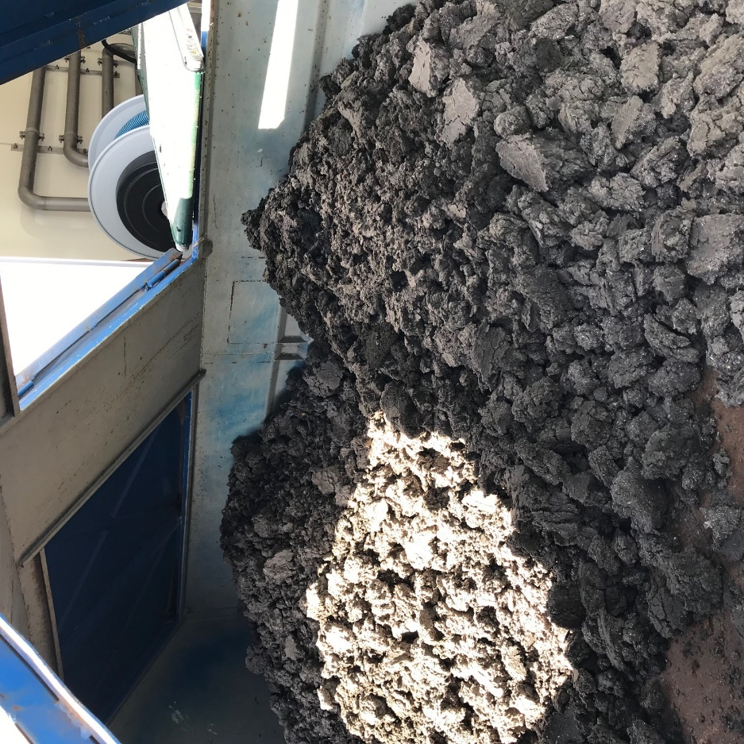**

**This case study has been carried out as part of the Interreg project STEP, South Baltic Program**

Contents

[Introduction 3](#_Toc18660723)

[Aim 4](#_Toc18660724)

[Method 4](#_Toc18660725)

[Pilot plant set-up 4](#_Toc18660726)

[Sampling and analysis 6](#_Toc18660727)

[Result and discussion 8](#_Toc18660728)

[Reduction of heavy metals 9](#_Toc18660729)

[Nutrients 9](#_Toc18660730)

[The handling of external sludge 10](#_Toc18660731)

[Supernatant 10](#_Toc18660732)

[Trace elements 11](#_Toc18660733)

[Improvment of slude quality 12](#_Toc18660734)

[Conclusions 13](#_Toc18660735)

[Practical implications 13](#_Toc18660736)

## Introduction

In rural areas in Sweden it is common for households to store sludge from e.g. toilets or dishwashers in septic tanks. These tanks are collected once a year by trucks and emptied at the municipal wastewater treatment plant (WWTP). There the sludge is treated together with incoming wastewater. The sludge from these septic tanks have often been found to have elevated levels of heavy metals. Experiences from wastewater utilities indicate that this type of external sludge, gathered from rural areas, should be handled separately. If dewatering is done exclusively on this fraction it would still be possible to add the supernatant, which would ideally have a low metal content, to the ordinary wastewater treatment stream.

Höör and Hörby wastewater treatment plants (now on referred to as Höör WWTP and Hörby WWTP) have been experiencing relatively elevated levels of heavy metals in the treated sludge (Table 1). Since there are no heavy industries connected to the networks, the reason for the observed levels are thought to be the septic tanks.

In total, there are about 7 000 septic tanks that need emptying at the treatment plants. Since these plants in total treat the water from 22 000 persons, the external sludge represents a considerable share of the incoming load (Table 2). The bed rock in the area have been found to have elevated levels of lead (Pb) and cadmium (Cd). According to analyses that has been carried out, this is likely the source of the heavy metals ending up at the WWTP. Therefore, an alternative method of separation is needed. The sludge from the septic tanks should ideally not be emptied into the regular wastewater inflow.

Table 1. Average sludqe quality on outgoing fraction from the treatment plant compared to the external sludge for Höör and Hörby. Values within parentheses are measured peak levels.

|  |  |  |  |  |  |  |  |
| --- | --- | --- | --- | --- | --- | --- | --- |
| Heavy metals | Existing regulation | New proposal for legislation | Average sludge Hörby WWTP | Average external sludge Hörby WWTP | Average sludge Höör WWTP (no lime) | Average slude slam Höör WTTP (lime) | Average external sludge Höör WWTP |
| Pb  (mg/kg TS) | 100 | 25 | 8,8 | 13 | 33 | 16 | 68 (750) |
| Cd  (mg/kg TS) | 2 | 0,8 | 0,9 | 0,9 (1,8) | 2,2 | 1 | 1,3 (16) |
| Cu  (mg/kg TS) | 600 | 475 | 400 | 340 | 913 | 485 | 417 (1200) |
| Cr  (mg/kg TS) | 100 | 35 | 19 | 16 | 15 | 10 | 24 |
| Hg  (mg/kg TS) | 2,5 | 0,6 | 0,4 | 0,56 (1,4) | 0,9 | 0,3 | 0,32 |
| Ni  (mg/kg TS) | 50 | 30 | 11 | 15 | 13 | 8 | 28 (150) |
| Zn  (mg/kg TS) | 800 | 700 | 480 | 770 (1300) | 760 | 420 | 670 (2400) |
| Cd/P |  |  | 45 | 94 (186) | 85 | 69 | 128 (1600) |

Table 2. Percentage of metals which the external sludge are contributing at the Höör treatment plant. The data comes from an internal report.

|  |  |  |  |  |  |
| --- | --- | --- | --- | --- | --- |
| Year | Lead (Pb)  % | Cadmium (Cd) % | Copper (Cu) % | Nickel (Ni) % | Zinc (Zn) % |
| 2013 | 52,9 | 36,5 | 9,0 | 81,0 | 25,6 |
| 2014 | 33,3 | 11,1 | 15,6 | 40,6 | 23,0 |
| 2015 | 70,0 | 15,0 | 17,1 | 45,4 | 27,2 |

## Aim

The main aim is to investigate to what extent the heavy metal inflow to the treatment plant can be reduced by a separate handling of the external sludge.

It is also expected that the organisation will receive valuable experiences from running this type of new treatment design. Hopefully this could form basis for future investments.

## Method

### Pilot plant set-up

The pilot plant set up with a separate handling process for the external sludge can be seen in Figure 1. The plant was operational from the 15 April to the 16 May 2019. Although the treatment plant in Höör had been found to have higher levels of heavy metals, the decision was taken to set-up the pilot plant at the plant in Hörby. This had to do with practical issues. More space was available in Hörby and this facility had a pool available for intermittent storage of the sludge.

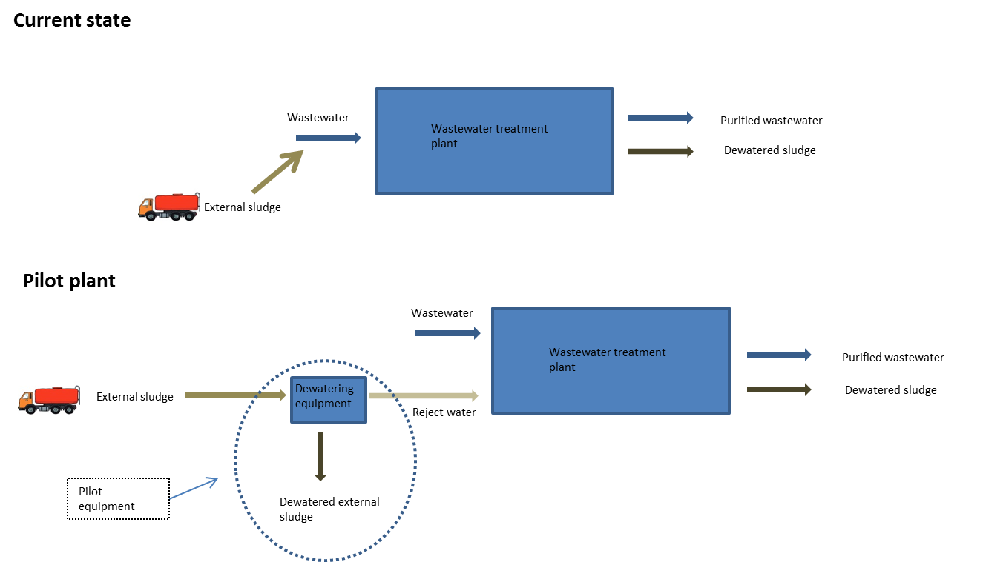

Figure 1. The pilot plant set-up during the phase of operation.

A roto-sieve and a wash press were hired from a consultant. After the preliminary step, the sludge was led to a pool for intermediate storage (this was done since the capacity to handle the water differed between the process steps) before it was pumped to the dewatering step (Figure 2). To avoid foul smell, the dewatered sludge was stored in a covered container. The polymer used during the first three weeks was Superfloc C-1592RS. The last week Superfloc SD-6065 was used. The roto-sieve and the wash press was operating during working hours.

|  |  |
| --- | --- |
| cid:a6fb2456-f64e-4843-8a7b-012b390174c8@unikom.se  Figure 2. Roto siev and wash press | cid:27262bba-fa93-435d-86b7-96cf4b18b88d@unikom.se  Figure 3. Dewatering equipment |

Supernatant

Dewatered sludge

Polymer

Analysis of supernatant

Analysis of sludge

Washed larger particles

Sludge

Analysis of dewatered sludge

Figure 4. The process for the handling of external sludge and the points of analysis.

Typically, two to three trucks carrying sludge are emptied at Hörby WWTP per day. During the trial period, the trucks were emptied in a separate receiver instead of directly in the wastewater inflow. An exception was made for the trucks carrying sealed tanks as these were considered not to be containing elevated levels of metals.

### Sampling and analysis

Analyses have been carried out on the pre-screened sludge, the screened sludge, the supernatant and the dewatered sludge. Flows and operational data has been noted every day.

Sampling was performed once every ten minutes. For the dewatered sludge, the samples have been weighed to a daily composite. The samples were frozen and then mixed to a weekly composite.

|  |  |
| --- | --- |
| K:\Höör - Tekniska\Mittskåne Vatten\17_ Projekt\_SPARAS_1_Pågående projekt\South Baltic\STEP\WP3\Akt 3.5 Pilotanläggning\Bilder\Studiebesök\IMG_8922.jpg  Figure 5. Dewatered external sludge. | cid:53febfd4-9cf8-4cca-b04a-184da8561b8c@unikom.se  Figure 6. Sampling of the screened sludge. |

In total, four weekly composite samples and ten daily samples were sent to a certified laboratory for metal analyses. Screened sludge, supernatant and dewatered sludge were analysed in this manner. Further, the dewatered sludge was analysed for the content of 60 trace elements. According to Swedish sludge quality standards, the operator of treatment plants should analyse 60 trace elements. Among these it is important to trace cadmium, lead and mercury. A composite sample from the sludge was taken and then analysed for all 60 trace elements. This was based on a dispersal of phosphorous around 22 kg/ha. Analyses concerning BOD and COD were done for the supernatant to investigate the treatment capacity of this fraction.

|  |  |
| --- | --- |
| cid:517d22c9-6d17-4b9c-816e-65c5b1e1039f@unikom.se  Figure 7. Sampling of the supernatant. | cid:6890d26d-ea64-45ea-be5c-669ca61f3cbc@unikom.se  Figure 8. Screened sludge being emptied for intermediate storage. |

Sampling of the supernatant was done from the bucket used for intermediate storage of the water. A device to prevent coarser sediment from ending up in the water sample was placed at the inlet of the sampling hose.

The various fractions have been analysed in different manners. The supernatant and the screened sludge have been analysed as ”wastewater”, while dewatered sludge has been analysed as ”sludge”. This means that different methods have been used for the same compound. This will undoubtedly be a source of error but nevertheless it has been necessary given the difference in material between the stages.

Table 3. Methods used to analyse the samples.

|  |  |  |
| --- | --- | --- |
| Compound | Screened sludge/Supernatant | Dewatered sludge |
| Heavy metals (Pb, Cd, Cu, Cr, Ni, Zn) | ISO 17294 | EN 16174, EN ISO 11885 |
| Mercury (hg) | SS-EN ISO 15587-2, EN 1483 | EN 16174, ISO 16772-1 |
| Ammonium-nitrogen | ISO 15923-12013 B | St.Methods 18th 4500B+E |
| Total nitrogen | SS-EN 12260:2004 | SS-EN 16169:2012 |
| Total phosphorous | SS-EN ISO 15681-2:2005 | EN 16174, EN ISO 11885 |
| Dry matter | SS 028113-1 | SS-EN 12880-1:2000 |
| Loss on ignition | SS 028113-1 | SS-EN 12879-1 |
| pH | SS-EN ISO 10523:2012 | SS-EN 15933:2012 |

## Result and discussion

The pilot plant operated without major malfunctions during the trial period. Details on the operation can be found in Table 4. The reason why the volumes in Table 4 are not completely in accordance are because some flows have been calculated whereas some have been measured. A smaller malfunction resulted in the pool being emptied and this sludge couldn’t be treated in the desired why but was instead released to the wastewater inflow to the WWTP.

The external sludge was observed to be easily dewatered and the level of dry matter was in the interval of 28 to 41%. It would have been of interest to estimate the dosage of polymer but because of malfunctions there are no reliable information. According to the consultant which delivered the dewatering equipment, a typical dosage of polymer for the dewatering of external sludge can be found in the interval of 5 – 6 kg/ton dry matter.

Table 4. Details on the operation of the plant.

|  |  |  |
| --- | --- | --- |
| Days of operation | Days when the plant was running. No activity during weekends. | 20 |
| Amount of treated external sludge (m3) | The amount being delivered by the trucks | 211 |
| Amount of pre-treated sludge (m3) | Sludge that passed through the preliminary screening step | 202 |
| Volume water used for flushing – roto sieve and wash press (m3) | Added water due to cleaning | 10 |
| Volume water used for flushing – dewatering (m3) | Added water for the cleaning of equipment and for the mixing of polymer | 64 |
| Amount polymer (m3;0,1% solution) | Mixing of polymer solution | 24 |
| Amount polymer (m3;concentrate) | Amount liquid concentrate,  Superfloc C-1592RS  Superfloc SD-6065 | Ca 0,005  Ca 0,01 |
| Volume supernatant m3 | Supernatant from sludge dewatering equipment, including for flushing. | 242 |
| Amount dewatered sludge (tonnes) | Dewatered sludge from the equipment | 1,72 |
| Number of trucks | Number of trucks which has emptied external sludge into the inlet to the pilot plant | 23 |
| Amount screened material m3 | Amount of screened material. | 0,2 |

### Reduction of heavy metals

In Table 5, the total amount of heavy metals for the different fractions has been calculated (i.e. pre-treated sludge, supernatant and dewatered sludge). Theoretically, the amount of metals in the supernatant together with that in the dewatered sludge should be equal to the amount in the pre-treated sludge, but this is not the case. The reason for this is likely because different methods have been used to measure the various phases.

Although the amount of metals is not in agreement, it is possible to see that the largest share of metals ends up in the dewatered sludge, not the supernatant. Therefore, it has been demonstrated that this indeed is one way to decrease the level of metals to WWTP:s. This is the case for all metals, however, some bind harder to the sludge than others (e.g. nickel and zinc).

Table 5. Amount of metals in the pre-treated sludge, the supernatant and the dewatered sludge, calculated based on concentrations and volume in the various fractions. The share of heavy metals in the supernatant compared to the dewatered sludge can also be seen.

|  |  |  |  |  |
| --- | --- | --- | --- | --- |
| Metal | Amount in pre-treated sludge (g) | Amount in supernatant (g) | Amount in dewatered sludge (g) | % supernatant/dewatered sludge |
| Pb | 8,55 | 0,47 | 6,29 | 7/93 |
| Cd | 0,66 | 0,059 | 0,40 | 13/87 |
| Cu | 525 | 17,39 | 358 | 5/95 |
| Cr | 6,40 | 0,38 | 5,70 | 6/94 |
| Hg | 0,25 | \* | 0,18 | - |
| Ni | 8,3 | 1,30 | 5,59 | 19/81 |
| Zn | 789 | 54,51 | 501 | 10/90 |

\*Below detection limit.

### Nutrients

The share of nitrogen and phosphorous was higher in the supernatant compared to the heavy metals. Since the WWTP:s are constructed to handle these compounds, the observed levels are not considered a problem. On the contrary, a high load of phosphorous is wanted as this means that more can be circulated. However, it should be noted that an adequate method to extract phosphorous from the sludge must be used.

Table 6. Level of nutrients in the various fractions.

|  |  |  |  |  |
| --- | --- | --- | --- | --- |
|  | Amount in pre-treated sludge (kg) | Amount in supernatant (kg) | Amount in dewatered sludge (kg) | % supernatant/external sludge |
| N-tot | 60 | 35 | 19 | 65/35 |
| P-tot | 10 | 4 | 3,9 | 53/47 |

### The handling of external sludge

The external sludge generated by the pilot plant still must undergo treatment. Swedish regulations stipulate that the sludge sorts under domestic waste. In Table 7 a comparison is made between the dewatered sludge from the pilot plant compared to the ”ordinary” sludge generated by the Hörby WWTP as well as the threshold limits stipulated in Swedish regulations.

Table 7. Comparison of dewatered external sludge and outgoing sludge from WWTP as well as the threshold limits for the recirculation of sludge.

|  |  |  |  |
| --- | --- | --- | --- |
|  | Metal levels in dewatered external sludge  (mg/kg dry matter) | Metal levels in outgoing sludge from Hörby WWTP (2018-2019) (mg/kg TS) | Threshold limit for sludge recirculation (mg/kg TS) |
| Pb | 10,97 | 8 | 100 |
| Cd | 0,70 | 0,71 | 2 |
| Cu | 624 | 400 | 600 |
| Cr | 9,94 | 20 | 100 |
| Hg | 0,32 | 0,22 | 2,5 |
| Ni | 9,75 | 10,6 | 50 |
| Zn | 873 | 467 | 800 |
| Cd/P | 103 | 36 |  |

According to the analyses, the dewatered external sludge will not be permitted for recirculation on arable land, the levels of copper (Cu) and zinc (Zn) were found to be exceeding the threshold limit. Thus, it would seem like some metals form stronger bonds to the sludge than others.

### Supernatant

The content contained relatively elevated levels of nutrients and BOD while the metal concentrations were found to be below the concentrations in the incoming wastewater and also legislation stipulated by Mittskåne water. The ratio cadmium/phosphorous was also found to be below the normally observed.

Table 8. The supernatant compared to incoming wastewater to Hörby WWTP and Mittskåne water separate regulation.

|  |  |  |  |
| --- | --- | --- | --- |
|  | Level in supernatant (mg/l) | Incoming to Hörby WWTP  (mg/l) | Mittskåne water regulation  (mg/l) |
| BOD | 590 | 220 |  |
| COD | 940 | 424 |  |
| Tot-N | 143 | 44 |  |
| Tot-P | 18 | 4,7 |  |
| NH4-N | 125 | 292 |  |
| Pb | 0,0019 | 0,00391 | 0,05 |
| Cd | 0,00024 | 0,0002961 | Should not exist |
| Cu | 0,072 | 0,1391 | 0,02 |
| Cr | 0,00159 | 0,00831 | 0,05 |
| Hg | <0,1 | 0,000111 | Should not exist |
| Ni | 0,0054 | 0,0071 | 0,05 |
| Zn | 0,225 | 0,2111 | 0,2 |
| Cd/P | 8 | 51 |  |

1 The levels are compiled from analyses done within the Interreg project Euroslam (2011-2014)

2 The levels are compiled from internal analyses (not from certified laboratories).

### Trace elements

In a society several different substances and chemicals are being used, these chemicals will end up in the sewage sludge.

All metals, except lead chromium and mercury, were found to exceed the threshold limits and hence cannot be dispersed on arable land (Table 9). The metals in Table 10 were found to have an accumulation rate exceeding 0,2 % and hence are screened as important to work with according to Swedish standards.

Table 9. Proportion of metals based on a phosphorus dispersal of 22 kg/hectare per year.

|  |  |  |  |
| --- | --- | --- | --- |
| Metal | Added from sludge (g/ha) | Threshold limits (g/ha) | % of threshold limit |
| Pb | 37,29 | 25 | 149% |
| Cd | 2,61 | 0,75 | 348% |
| Cu | 2124,88 | 300 | 708% |
| Cr | 38,90 | 40 | 97% |
| Ni | 33,80 | 25 | 135% |
| Zn | 2680,24 | 600 | **447%** |
| Mg | 0,85 | 1,5 | **57%** |

Table 10. Trace elements with a higher accumulation rate than 0,20 % per year.

|  |  |  |  |  |  |  |
| --- | --- | --- | --- | --- | --- | --- |
| Compound | Amount (mg/kg DM) | Added from sludge (g/ha) | Level in standard soil (mg/kg) | Amount in standard soil (g/ha) | Accumulation (%) | Reduplication rate (year) |
|
| Ag | 1,27 | 3,41 | 0,11 | 343,75 | 0,99 | **101** |
| Au | 0,438 | 1,18 | 0,005 | 15,625 | 7,52 | **13** |
| Bi | 5,23 | 14,03 | 0,16 | 500 | 2,81 | **36** |
| Cd | 0,97 | 2,61 | 0,17 | 531,25 | 0,49 | **203** |
| Hg | 0,316 | 0,85 | 0,043 | 134,375 | 0,63 | **158** |
| Sb | 0,88 | 2,36 | 0,25 | 781,25 | 0,30 | **331** |
| Sn | 17,1 | 45,88 | 1,8 | 5625 | 0,82 | **123** |
| S | 6580 | 17653,66 | 400 | 1250000 | 1,41 | **71** |

### Improvement of sludge quality

Based on the results from the analyses of the sludge, an attempt was made to assess how the sludge quality would be affected with the pilot plant set-up. The levels are calculated based on average levels of metals and dry matter. Hence, the result should only be viewed as an indication of sludge improvement. According to the calculated levels, an interval of 81-95% was determined for how much of the metals that would end up in the dewatered sludge. However, since there were some uncertainties concerning the calculation, it was decided to change the interval to 80-90%. Based on this a reduction in metal content of about 5-15% can be achieved by external handling Table 11.

Table 11. Total amount of metals in the sludge from the WWTP and external sludge and the reduction in metal content on outgoing sludge if the amount is reduced by 80 and 90% respectively.

|  |  |  |  |  |
| --- | --- | --- | --- | --- |
| Metal | Metal amount in sludge (mg/kg TS) per year from Hörby WTTP1 | Calculated metal amount in external sludge per year (mg/kg TS) | Reduction of metals in outgoing sludge from WWTP at 90% reduction. | Reduction of metals in outgoing sludge from WWTP at 80% reduction. |
| Pb | 3,3 | 0,45 | 12% | 11% |
| Cd | 0,3 | 0,03 | 9% | 8% |
| Cu | 156 | 16 | 9% | 8% |
| Cr | 7,4 | 0,47 | 6% | 5% |
| Hg | 0,2 | 0,02 | 9% | 8% |
| Ni | 4,2 | 0,49 | 11% | 9% |
| Zn | 182 | 30,1 | 15% | 13% |

1Average value 2016-2018

2 The values were calculated based on average values from the analyses on external sludge in this project as well as analyses done on external sludge in 2018.

## Conclusions

The project has shown that the inflow of metals to the WWTP can be reduced by a separate handling of the external sludge. Additionally, the quality of the supernatant is sufficient for direct treatment at the WWTP.

The operation and maintenance are relatively straight forward and the sludge easy to dewater. A full-scale version of the pilot plant should not entail major malfunctions. Before the commencement of operations, there was suspicion that foul smell could occur, however this was found not to be a major issue. The only problem came from within the WWTP where foul smell was sensed coming from the pool for intermediate storage.

The dewatered external sludge was found to have elevated levels of copper and zinc. This means that the sludge cannot be spread on arable land. Combustion is one alternative.

Apart from external sludge from households, it should also be investigated if external sludge from smaller WWTP in Höör and Hörby should be treated in the same way. There are strong reasons to assume that this sludge as well will have elevated levels of metals.

## Practical implications

For Höör and Hörby it is probably enough with one permanent facility for the treatment of external sludge. The cost associated with investments are high and therefore it will probably be difficult to motivate one facility in each municipality. The most likely place would then either be Höör or Hörby WWTP. However, it should be noted that it is not necessary to have this type of facility at a WWTP. What is necessary is a wastewater pipe for outgoing supernatant. WWTP:s do, however, have the advantage of being a protected environment with control over e.g. smell.

There are currently legislations being elaborated which, if they are passed, would prohibit the dispersal of sludge on arable land. If this will turn out to be the case, then one can question the logic behind treating sludge in the manner described in this report. However, it could still be worthwhile to handle the sludge externally. It could be used to prevent major pollutants ending up at the WWTP and destroying treatment processes.