**STEP**

**– National rules comparison** (deliverable 3.2)

**– Use of sludge as fertilizer in agriculture – focus on barriers** (deliverable 3.3)

The different countries in EU have different traditions and issues about the use of sludge in agriculture, and the national legislation is also different, although the same EU-directive (86/278/EEC) regulate Limit Values of heavy metals in sludge from Waste Water Treatment Plants (WWTP) when used as fertilizer in agriculture (see table 1 and 3 below).

In the STEP projects deliverable 3.2 and 3.3 we describe and compare the national rules and the issues and barriers to the use of sludge in agriculture, from the perspective of each partner and the specific regulation their country.

Our common view on the subject, based on an ecological approach, can be explained in a few basic sentences:

Sludge from WWTP’s:

* is a valuable biomass, and as much as possible of the nutrients in the treated waste water should be collected in the sludge / as little as possible of nutrients, organic matter and chemical in the treated waste water should pass onto the recipients.
* should, if possible, be used as fertilizer in agriculture, so the valuable nutrients are recycled, and the carbon in the sludge is build into the soil, instead of quickly released as CO2.
* should, if possible, be digested to produce biogas / energy, thus replacing fossil fuels

**Comparison of national rules in general**

A thorough comparison of limit-values of different compounds in sludge is published in the EU-report: **Disposal and recycling routes for sewage sludge,** Part 2 - Regulatory report October 2001:

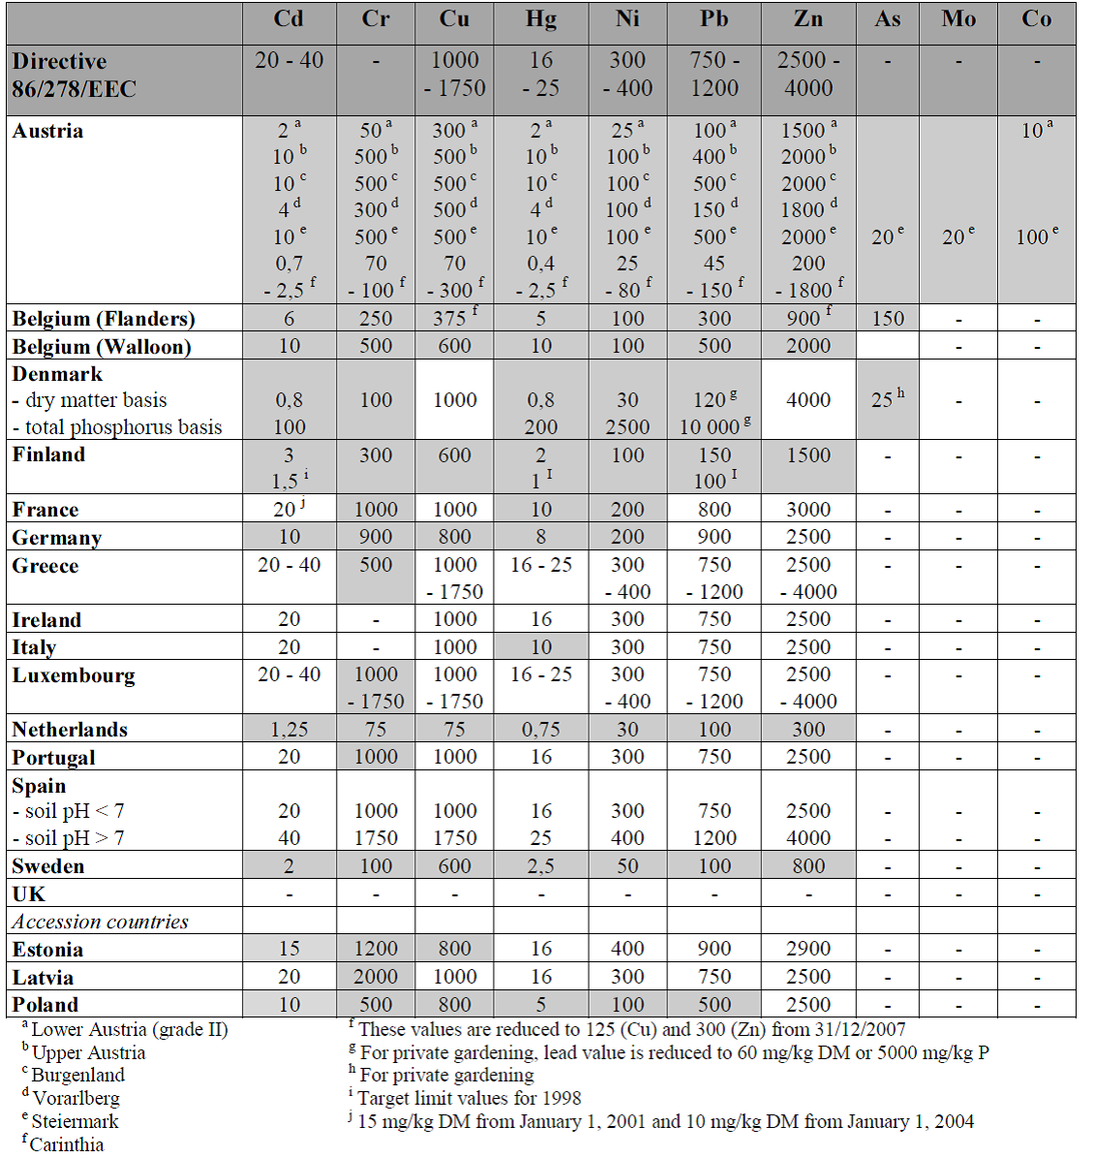



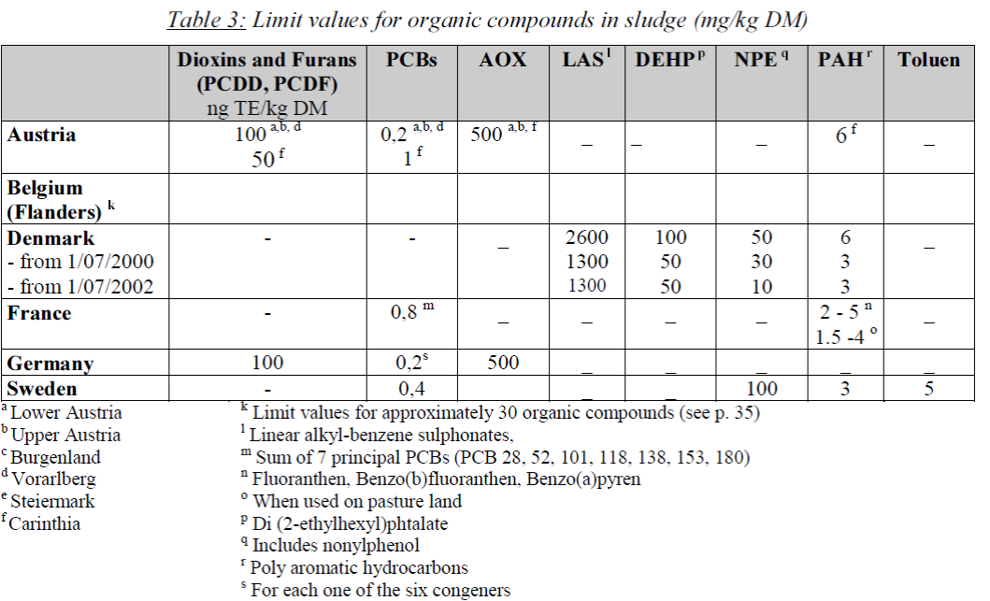

The report states:

“In particular, the limit values for concentrations of heavy metals in sludge are lower than the limit

values specified in the Directive in a majority of countries. In five countries (Belgium -Flanders-,

Denmark, Finland, the Netherlands and Sweden), the limit values for heavy metals in sludge are

even much lower…

In the majority of Member States, the specific regulations which have been introduced covering the isposal and recycling of sludge mainly concern the use of sludge in agriculture, while the disposal

of sludge is addressed by general legislation on landfill and incineration of waste ..

in the Directive,very few specific provisions for sludge from septic tanks are included in

national regulations.”

Link: <http://ec.europa.eu/environment/archives/waste/sludge/pdf/sludge_disposal2.pdf>

The STEP partners have confirmed that the contemporary limit-values are still the same in their countries as shown in the tables above.

1. DENMARK - Bornholm

The national rules about use of sludge in agriculture has essentially been unchanged for many years. In generally the sludge quality I Denmark has improved during the years, and the majority of the sludge is used in agriculture (about 75%)

On Bornholm all the sludge from wastewater treatment is used as fertilizer in agriculture. Sludge from WWTPs and septic tanks are treated separately.

**Heavy metals:**

Cadmium – is usually the heavy metal in sludge that might come closest to, or surpass, the limit value in DK. ThIs is not surprising when we take a look at the table comparing Limit Values: Denmark has one of the lowest limits for Cadmium in EU: 0,8 mg/kg DM (or 100 mg/kg P), where the directive operates with 20-40 mg/kg DM

One of the WWTP’s on Bornholm (Boderne) sometimes come close to, and occationally surpass, the Danish limit value of Cadmium. It is possible that the large amount of excess water this WWP receives contributes to this situation.

The low Danish Limit value for Cadmium is generally not a barrier to agricultural use of sludge in Denmark or Bornholm, and it gives us a natural focus on industrial wastewater permissions, where the allowed concentration of Cadmium in wastewater is usually low.

Eg: Mass balance calculations in relation to the Cadmium input to Rønne WWTP, resulted in an allowed concentration of max 0,2 microgram/l in the condensed water from the power plant in Rønne, when the main boiler was rebuild from burning coal to woodchips in 2016. In a permit from 2018 the same maximum concentration is allowed for a new facility on Rønne harbor, to recieve wastewater from Cruise Ships.

**Organics**

Denmark and Sweden are some of the few countries in EU where the national legislation has Limit Values for groups of organic compounds:

LAS: Linear Alkylbenzene Sulphonates are the most extensive used anionic detergents in cleansing agents. Despite the high separation efficiency in sewage treatment plants LAS outlet concentrations are in the range 0,02 – 0,9 mg LAS l-1 (Berna et al. 1989; Berna et al. 1991). LAS are only slowly degradable in anoxic environments and may become concentrated in marine environment. In estuaries and near-shore marine waters, LAS has been found in concentrations that affect normal growth and development of marine

organisms (Christensen et al. 1998; Hansen et al. 1997; Kimerle 1989). LAS are now on the Danish Environmental Protection Agency’s list of undesirable substances in the group of non-anaerobic degradable substances.

PAH: Polycyclic aromatic hydrocarbons are of interest because of their potential toxic and carcinogenic properties. Due to their low water solubility and their high affinity for organic matter, PAHs are easily concentrated in sewage sludge. Under methanogenic conditions, PAH removal about 50% has been demonstrated; under aerobic conditions, the aerated process enhanced PAH removal up to 90%. (E. Trably · D. Patureau · J.-P. Delgenes, 2005)

In one of the WWP’s on Bornholm the limit value of PAH has a few times been surpassed. This problem has been solved by composting.

NPE: NPE are a group of nonionic detergents which are present in many laundry and cleaning agents. Consequently, research regarding mineralisation of theses compounds became important to the discussion

about whether the agricultural sector could continue as a receiver of sludge in the future.

#### DEHP (diethylhexylphthalat) belongs to a group of phthalate esters which is used in large amounts as

softner or plasticizer in Polyvinyl chloride (PVC), a hard, brittle plastic, only when softeners are added that it becomes softer and pliable and can be made into floors and other products. In soft PVC floorings these are not securely bound in the matrix, but can evaporate or wash off from the products or escape into the room as a result of wear.

DEHP in sludge: Most of the DEHP in wastewater is decomposed in the WWTP’s. But a large amount is also adsorped in the sludge. In 1992 it was estimated that 7 tons DEHP per year was retained in sludge from Danish WWTP’s.

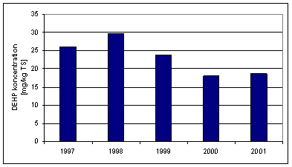

Koncentration of DEHP in sludge from Danish WWTPs - 1997 til 2001. Data from the Danish EPA.

**“Psykological barriers”**

“The Arla directive”: The mayor Danish diary-company, Arla, don’t allow their milk suppliers to use sludge on fields where their cows feed.

**Sludge from Septic tanks**

Sludge from septic tanks is also regulated by the same national rules as sludge from WWTPs. On Bornholm the sludge from septic tanks (app. 5000) is composted to reduce the content of organic compounds, eg. LAS, below the limit values. The sludge Is composted with straw cut in bits, and then mixed with burned lime, before it is used as fertilizer in agriculture.

This is a cheap, energy-effective way to handle sludge from septic tanks. A problem with this is misdisposed inorganic material eg. Plastic bits, in the sludge, that is an unwanted (mostly visual) pollution of the fields.

A case study between different practical methods of handling sludge from septic tanks is also done in the STEP-project (see: xxxxxx)

**Table 1: Comparison of heavy metals and organics in sludge from septic tanks and WWTP (Rønne)**

|  |  |  |  |
| --- | --- | --- | --- |
|  | Analysis of composted sludge from septik tanks (mean) | Analysis of sludge from WWTP (Rønne- mean) | Limit values |
|  | mg/kg DM | mg/kg DM | mg/kg DM |
| Pb | 26 | 12 | 120 |
| Cd | **1,4** | 0,8 | 0,8 |
| Cu | 258 | 168 | 1.000 |
| Cr | 13 | 10 | 100 |
| Hg | 0,7 | 0,3 | 0,8 |
| Ni | 17 | 10 | 30 |
| Zn | 1.070 | 495 | 4.000 |
|  |  |  |  |
| Cd/P (mg/kg P) | **76** | 35 | 100 |
| Hg/P (mg/kg P) | 38 | 14 | 200 |
|  |  |  |  |
| Tot N (g/kg DM) | 29,5 | 48,3 |  |
| Tot P (g/kg DM) | 18,5 | 22,8 |  |
|  |  |  |  |
| LAS | 423 | < 108 | 1.300 |
| sumPAH | 1,7 | 0,6 | 3 |
| sumNPE | 3,4 | 1,5 | 10 |
| DEPH | 2,5 | 5,5 | 50 |
|  |  |  |  |

1. SWEDEN - Höör/Hörby

I Sverige omhändertas nära en miljon ton slam varje år. I dag sprids mellan 25 och 30 procent av avloppsslammet på jordbruksmark. Resten används vid jordtillverkning och deponitäckning alternativt lagras eller används på annat sätt.

I Sverige finns ett certifieringssystem som heter Revaq. Revaq är ett system med syfte att minska flödet av farliga ämnen till reningsverk, skapa en hållbar återföring av växtnäring samt att hantera riskerna på vägen dit. Certifieringen innebär att reningsverket bedriver ett aktivt och strukturerat uppströmsarbete, arbetar med ständiga förbättringar och är öppen med all information. Revaq drivs idag av Svenskt Vatten. Kopplat till Revaq finns en styrgrupp där lantrbrukarnas branschorganisation och Livsmedelsföretagen deltar  och samverkan sker även med Naturvårdsverket. Revaq startade 2008 och nu är 42 reningsverk certifierade. Detta innebär att ungefär hälften av allt slam som produceras i Sverige är Revaqcertifierat.

Vid arbete med Revaq ligger fokus på:

• strukturerat arbetssätt

• systematiskt uppströmsarbete

• spårbarhet

• slamkvalitet enligt specificerade krav

Några av kriterierna för att ett slam ska vara Revaqcertifierat är följande:

* Slammat ska vara hygieniserat för att undvika smittspridning
* Lakvatten från deponier får inte vara anslutet till reningsverket
* Det finns regler för maximal tillförseln av ett antal metaller till åkermark beräknat som g per hektar och år. Dessa gränser är lägre än vad lagstiftningen anger.

Lagstiftningen i Sverige gällande användning och spridning av avloppsslam är från 1994. Under de senaste 15 åren har riksdag och regering arbetat med att ta fram en ny lagstiftning men någon ny lagstiftning har inte blivit beslutad men det finns förslag på ny lagstiftning.

**Heavy metals**

Av nedanstående sammanställningar kan man se att halterna av vissa metaller i framtiden kan medföra att det blir svårt att avsätta både avloppslam från Höör och Hörby till åkermark utifrån det svenska regelverket. För slammet från Höör är det bly, kadmium, koppar och ev. kvicksilver som inte kommer att klara föreslagna gränsvärden. För Hörbys slam är det främst kadmium som inte klarar föreslagna gränsvärden.

Höör och Hörby ligger inom ett område där det förekommer höga halter bly och kadmium I berggrunden. Då bly och kadmium har visat sig inte bara förekomma i berggrunden utan även i jordlagren är det inte omöjligt att spillvattenledningar med stort inläckage tar in bly- och kadmiumhaltigt vatten.

|  |  |  |  |  |
| --- | --- | --- | --- | --- |
| Metaller | Gränsvärde nuvarande lagstiftning | Gränsvärde föreslagen ny lagstiftning (2030) | Metallinnehåll Lybyverket  (2015-2018) | Metallinnehåll Ormanäs reningsverk |
| Pb | 100 | 25 | 6,1-10 (8,6) | 3-55 (13) |
| Cd | 2 | 0,8 | 0,45-0,96 (0,75) | 0,31-1,3 (0,8) |
| Cu | 600 | 475 | 390-460 (411) | 150-560 (419) |
| Cr | 100 | 35 | 15-24 (19) | 6,2-12 (8,7) |
| Hg | 2,5 | 0,6 | 0,19-0,94 (0,31) | 0,06-0,61 (0,23) |
| Ni | 50 | 30 | 8,6-14 (11) | 4,3-11 (7,6) |
| Zn | 800 | 700 | 430-570 (480) | 110-570 (7,6) |
| NH4-N | - | - | 6,4-19 (12) | 1,1-3,7 (2,5) |
| N-tot | - | - | 47-68 (61) | 16-30 (24) |
| P-tot | - | - | 17-24 (20) | 4,5-19 (12) |
| TS | - | - | (17) | (37) |

Vid jämförelse av svenska riktvärdena med lagstiftningen i resten av Europa så ser man att Sverige har lägre gränsvärde för de flesta metallerna, dvs det ställs hårdare krav på slamkvalitet I Sverige jämför med övriga länder I EU.

**Organics**

I Sverige finns det lagstifning som regelerar vilken halt som är tillåten i slam som ska spridas. Ämnena som regleras är PAH, PCB, Nonylfenol och Toluen. I nedanstående tabell är uppmätta halter sammanfattade och slam från Höör och Hörby ligger ofta under lagstadgade gränsvärde.

|  |  |  |  |  |
| --- | --- | --- | --- | --- |
| Organiska ämnen | Gränsvärde nuvarande lagstiftning | Gränsvärde föreslagen ny lagstiftning (2030) | Metallinnehåll Lybyverket  (2015-2018) | Metallinnehåll Ormanäs reningsverk |
| PAH | 3,0 |  | 0,15 | 1,6 |
| PCB | 0,4 |  | 0,01 | 0,15 |
| Nonyfenol | 50 |  | 2,2 | 0,01 |
| Toluen | 5,0 |  | 0,5 | 2,1 |

**“Psykological barriers”**

Det har varit en discussion I Sverige kring att gödsla med slam från det kommunala avloppsreningsverk. I slutet av 1990-talet och i början av 2000-talet var det slamspridningsstopp för spridning av slam från reningsverk. Tex ville inte företaget Arla att korna som producerar mjölk skulle få foder tillverkad av grödor som gödslats med slam. Lantbrukarnas Riksförbund, LRF, har vid flera tillfällen de senaste decennierna uppmanat sina medlemmar att inte sprida slammet på åkrarna, och i dag är det ca 30 procent av avloppsslammet från reningsverken som används som sådan gödsel. Det var utifrån dessa diskussioner som branschen började arbeta med förbättring av slamkvalite från reningsverk genom certifieringssystemet Revaq.

Den lagstiftning som gäller idag är från 1994 och i över 10 år har man I Sverige arbetat med en ny lagstiftning. De förslag som finns gällande ny lagstiftning innebär bland annat strängare regler för hygienisering och krav på återföring av fosfor till jordbruket. Riktvärdena för metaller är också lägre än I dagens lagstiftning.

Som ett led i arbetet för giftfria och resurseffektiva kretslopp tillsatte regeringen en utredning 2018 för att dels föreslå ett förbud mot att sprida avloppsslam, dels införa krav på att fosfor ska återvinnas ur avloppsslam. Regeringen vill skapa förutsättningar för en cirkulär ekonomi, där avfallet istället hanteras som en resurs. Målsättningen med utredningen är att fosfor ska återvinnas på ett giftfritt och säkert sätt från avloppsslam och kunna återanvändas i större utsträckning i jordbruket. Utredningen ska ta fram förslag på krav för att återvinna fosfor ur avloppsslam. Eftersom avloppsslam även innehåller miljö- och hälsoskadliga ämnen, läkemedelsrester och mikroplaster ska utredningen också ta fram förslag på ett förbud mot att sprida avloppsslam på jordbruksmark.

Ett förbud mot att sprida avloppsslam ska inte innebära ett hinder för utvinning av biogas. Syftet är att både energi och fosfor ska återvinnas ur avloppsslammet utan risk för att hälso- och miljöskadliga ämnen kommer ut i miljön. Uppdraget ska redovisas senast 15 september 2019.

**Sludge from Septic tanks**

I Höör och Hörby finns ca 6000 trekammarbrunnar. Slammet från dessa hämtas med bil och körs till reningsverket där det släpps på inkommande. Därefter behandlas slammet från trekammarbrunnar I reningsverkets process.

Vid undersökningar har det framkommit att det finns relativt stora mängder metaller i slam från trekammarbrunnar. Vid beräkningar framgår det att stora mängder av de metaller man hittar i utgående slam från reningsverket kommer från trekammarbrunnsslammet.

|  |  |  |  |  |  |
| --- | --- | --- | --- | --- | --- |
| Årtal | Bly  % | Kadmium % | Koppar % | Nickel % | Zink % |
| 2013 | 52,9 | 36,5 | 9,0 | 81,0 | 25,6 |
| 2014 | 33,3 | 11,1 | 15,6 | 40,6 | 23,0 |
| 2015 | 70,0 | 15,0 | 17,1 | 45,4 | 27,2 |

Tabellen visar den beräknade mängden metaller som tillförs via trekammarbrunnar. Beräkningarna beräknas utifrån analyser.

Inom STEP-projektet har det genomförts ett försök med att avvattna slam från trekammarbrunnar separat för att därigenom minska mängde metaller som tillförs reningsverket. Detta ska på sikt förbättra kvaliten på utgående slam från reningsverket vilket kan förbättra förutsättningarna att sprida slam på åkermark.

1. Lithurenia - Kleipeda
2. **Legislation review**

Directive 86/278/EEC is the main document defining the requirements on sludge management in agriculture in EU level. Well as the other Directives also have significant role on sludge management, this document contains national rules comparison with respect to Directive 86/278/EEC requirements.

Lithuanian legal system has 2 documents regarding wastewater sludge management in agriculture:

1. The main national document regarding transposition of Directive 86/278/EEC requirements into Lithuanian legislation is Environmental Protection Normative document LAND 20-2005: Requirements on the use of Sewage sludge for Fertilization and Reclamation[1] adopted by the Order of the Ministry of Environment.
2. Environmental requirements for composting, anaerobic treatment of biodegradable waste adopted by the Minister of Environment order[2]. Requirements determine the conditions for composting, anaerobic treatment of biodegradable waste, types of composted, anaerobically treated waste, requirements for the quality and use of compost, anaerobic fermentation. The main points, regarding sewage sludge management in agriculture:

* Composting or anaerobic treatment can be used for sludge I and II categories and A, B classes (according to LAND 20-2005).
* Compost is considered suitable for usage when the values of heavy metals in the compost made from sludge does not exceed the category II limits (according to LAND 20-2005).

It is necessary to mention, that new version of LAND 20-2005 document is planned to be adopted this year. At the moment new version of LAND 20-2005 is on coordination process with all responsible institutions and stakeholders involved. It is expected, that new document will come to the legal power this year. The main draft changes will be mention in this document below.

*LAND 20-2005: Requirements on the use of Sewage Sludge for Fertilization and Reclamation[3]*

The sludge management is regulated by the order of the Ministry of Environment – an Environmental Protection Normative Document LAND 20-2005 - Requirements on the use of Sewage Sludge for Fertilization and Reclamation (Hereinafter - Order). The order aims to regulate sewage sludge in agriculture, energy crops (fast growing plantations for the direct use as biofuels) and the cultivation of damaged areas (quarries, peat empty, closed landfills, roadbed, etc.) and dumpsites so that no negative effects are caused on soil, vegetation, animals and humans. Its requirements apply to household and municipal or similar industrial (e.g. food) waste water sludge.

Article 5.2 of the order defines treated sludge as biologically, chemically or thermally affected, stored for long time or undergone any other process that reduce its fermentability and the health hazards. The order provides limit values for heavy metal concentrations in sludge, soil and average annual loads. Two kinds of limit values are provided for the concentrations of heavy metals in soil – background limits (which influence the frequency of performing soil analysis), and maximum permitted concentration values – for sand/sandy loam and loam/clay soils.

Furthermore, the sludge is differentiated to categories (I, II, III – depending on heavy metal concentrations) (Table No. 1) and classes (A, B, C – depending on microbiological and parasitological parameters). Lithuanian legislation regulates the pathogen content of sludge – parameters considered are the following: Escherichia coli, Clostridium perfringens, helminth eggs and larvae as well as pathogenic enterobacteria (Table No.2).

**Sludge of III category or C class, as well as untreated sludge cannot be used.** Also, according to general rules on the use of sludge, regardless of category/class, it is forbidden to use sewage sludge on the areas near drinking water bodies, areas of surface water protection zones, and extensive karst areas. For agricultural purposes: (i) none of the categories/classes of sludge can be used on the areas planted with fruits and vegetables (excluding fruit trees), and also areas where soil pH is < 5.5; (ii) the use of II category sludge is prohibited on the grasslands, areas devoted for vegetables, fruits or crops, as well as if the concentration of heavy metals in the soil exceeds 70 % of the maximum permissible concentrations; it also cannot be used more often than every 3 years; (iii) on the areas for cultivation of vegetables and grassland or forage/feed crops, only A class and I category sludge may be used; areas for the cultivation of fruit crops and vegetables that are in direct contact with the soil and eaten raw, fertilized no later than 10 months before harvest and during harvest, grassland or forage crops – not later than three weeks before use (mowing or grazing); (iv) maximum amounts nutrients applied with sludge are: nitrogen – not more than 170 kg/ha per year, phosphorus – not more than 40 kg/ha per year; and (v) sludge should be worked into the soil within 2 days after spreading on the surface, and it cannot be spread if the air temperature is higher than 20 °C.

Table No.1 Sludge differentiated into categories according to heavy metals concentrations

|  |  |  |  |  |  |  |  |
| --- | --- | --- | --- | --- | --- | --- | --- |
| **Sludge category** | **Heavy metals concentration, mg/kg**  **(LAND 20-2005)** | | | | | | |
|  | **Pb** | **Cd** | **Cr** | **Cu** | **Ni** | **Zn** | **Hg** |
| **I** | <140 | <1,5 | <140 | <75 | <50 | <300 | <1,0 |
| **II** | 140-750 | 1,5-20 | 140-400 | 75-1000 | 50-300 | 300-2500 | 1,0-8,0 |
| **III** | >750 | >20 | >400 | >1000 | >300 | >2500 | >8,0 |
| **EU Directive 86/278/EEC limit values in sludge(mg/kgDM)** | **750-1200** | **20-40** | **-** | **1000-1750** | **300-400** | **2500-4000** | **16-25** |

Table No.2 Sludge differentiated into classes according to microbiological – parasitological parameters

|  |  |  |  |  |
| --- | --- | --- | --- | --- |
| **Sludge class** | **Faecal intestinal rod**  **(*Escherichia coli*),**  **col. number/g** | **Anaerobic clostridia**  **(*Clostridium perfringens*),**  **col. number/g** | **Helminth eggs and larvae**  **unit/kg** | **Pathogenic enterobacteria**  **col. number/g** |
| **A** | ≤ 1000 | ≤ 100 000 | 0 | 0 |
| **B** | 1001–100 000 | 100 001–10 000 000 | 1–100 | 0 |
| **C** | > 100 000 | >10 000 000 | > 100 | >1 |

The Order regulates also the use for recultivation and for fertilization of energy crops. In both cases, maximum allowed amount of sludge to be used is 100 tons of dry matter per hectare, but this can be increased if justified by a site remediation project and are proven to be environmentally safe. Moreover, there are limitations of these ways of sludge application – it cannot be used on surfaces when up to 0.5 km deep there is flow of underground water extracted for drinking water preparation; or the highest ground water level depth of the sludge application layer pad is less than 1 meter. Additionally, sludge can be used for energy crops fertilization only in areas where in the upper soil layer (not less than 1 m) the average filtration rate is less than 10–2 m/d. In turn, the sludge recultivated damaged areas later (though, not defined exactly) can be used to grow agricultural crops for human or animal consumption.

The Order contains rules of performing analyses of soil and sludge before its use. Before delivering the sludge to the user (not earlier than 30 days), the sludge must be analyzed in order to determine the dry matter content, pH value, total nitrogen (N) and phosphorus (P) concentration in dry matter, and microbiological/parasitological indicators. The latter, however, are not required to be measured if the sludge:

* was treated by raising the temperature above 70 °C and maintaining that for longer than 1 hour;
* was dried at 100 °C and higher temperatures;
* has undergone anaerobic, aerobic or lime (by increasing sludge pH>12 for longer than 2 hours, after 24 hours pH should be maintained at > 11.5) stabilization;
* Was prepared for composting – temperatures above 55 °C, maintaining at least 2 weeks.

The frequency of sludge analyses for heavy metal concentrations are determined depending on the load of waste water treatment plant, ranging from 12 times per year for a plant with capacity more than 50 000 PE to once per year for a plant with capacity less than 10 000 PE. At the same time, the Order does not explicitly indicate who is responsible for the conducting this analysis. However, it is stated as the responsibility of sludge supplier to keep the records regarding sludge usage (treatment, analyses results, and data on users of sludge).

Before the first application of sludge for agricultural purposes, soil should be also analyzed in order to determine its quality indicators: concentrations of heavy metals, texture and pH level. Further frequency of soil analysis depends on the results of the first tests (whether heavy metal concentrations do or do not exceed background limit values), and on category of sludge applied.

*New draft version of the Requirements for the use of sewage sludge for fertilization and recultivation [4]*

The draft document has the main proposals:

* Establishing the criteria for classifying sludge compost and sludge ferment (yeast) as a product. Maximum levels of heavy metals in sludge compost are proposed (as product). The draft order proposes that sludge compost, sludge ferment (yeast) that meets the criteria for product designation will have to be certified by the Ministry of Economy and can be used without fertilization plans: (i) Concentrations of organic pollutants (PCBs and PAHs) in sludge compost and sludge ferment (yeast) do not exceed the proposed limits; (ii) amount of undesirable admixture as (glass, metal, plastics, sprouting seeds, weeds, rhizomes, stones) in them does not exceed the permissible limits; (iii) microbiological-parasitological parameters do not exceed the requirements, etc.
* To tighten restrictions for heavy metal values from 2021 (Table No. 3), allowing water management and other companies to prepare for the implementation of this legislation, and to align with the Urban Wastewater Regulation, which requires canceling effluent (including cadmium) of priority hazardous substances by 2020.
* Only sludge of **category I** can be used in agriculture.

Table No. 3 Sludge differentiated into categories according to heavy metals concentrations (proposal)

|  |  |  |  |  |  |  |  |
| --- | --- | --- | --- | --- | --- | --- | --- |
| **Sludge Category** | **Heavy metals concentration, mg/kg** | | | | | | |
|  | Pb | Cd | Cr | Cu | Ni | Zn | Hg |
| **I** | <140 | <1,5 | <140 | <300 | <50 | <800 | <1,0 |
| **II** | 140-750 | 1,5-20 | 140-400 | 300-1000 | 50-300 | 800-2500 | 1,0-8,0 |
| **III** | >750 | >20 | >400 | >1000 | >300 | >2500 | >8,0 |
|  | **Heavy metal concentration from 2021, mg/kg** | | | | | | |
| **I** | <120 | <1,5 | <100 | <300 | <50 | <800 | <1,0 |
| **II** | 120-150 | 1,5-5 | 100-130 | 300-500 | 50-70 | <800-1500 | 1-1,5 |
| **III** | >150 | >5 | >130 | >500 | >70 | >1500 | >1,5 |

1. **Short review of the Sludge management at a National level**

Sludge is a wastewater treatment by – product (waste code is 190805). Where to use the sludge is a problem not only in Lithuania, but also in more developed countries. Worldwide there are no predominant ways of sewage sludge management – sludge can be incinerated, composted, also used for biofuel production, in agriculture, for energy crops (fast-growing green areas for direct use for biofuel production) and for damaged areas (quarries, landfills) recultivation. Therefore, when selecting sludge management methods, the country's ecological and economic situation is taken into account. In Lithuania we have 23 state projects sludge management facilities funded by EU: 12 sewage sludge digestion-drying plants, 2 drying facilities and 9 composting sites. Wastewater sludge treatment facilities capacity and locations are planned, taking into account the amount of sludge generated in the country.

According to Environmental Protection Agency statistical data (2017)[5], sludge managed in these ways:

* Used for fertilization and recultivation – 48,3%
* Used for composting – 38,7%
* Incinerated – 0,3%
* At landfills – 7,4%
* Other methods – 5,2%.

1. **Sludge usage review in a regional level – SC “Klaipedos vanduo” WWTP data**

The CHP (Combined Heat and Power) production as well as biogas’s digestates further utilization ensures the wastewater treatment process circularity’ principles implementation. However, some issues regarding heavy metals concentrations in the biogas residues are indicated. The concentration of the Cr is the biggest in the Klaipeda wastewater treatment plant and can exceed the concentration up to 84 mg/kg (Fig. 1) due to the chromium (III, VI) amount in sewage of such industrial companies as dyes and pigments production as well as wood preserving and chrome plating. The fluctuation of the nickel concentration in the Klaipeda sewage depends on its compounds’ usage for valves and heat exchangers, for nickel plating, color ceramics, batteries, and jewelry. Such toxic element as lead mostly comes with wastewater from paint, ceramic and batteries production, solder and pipes as well as from soils and streets. In addition, lowering the pH of wastewater can induce the higher concentrations of metals in the sewage. The heavy metals concentrations during the last three years (2014-2016) have tendency to decrease.

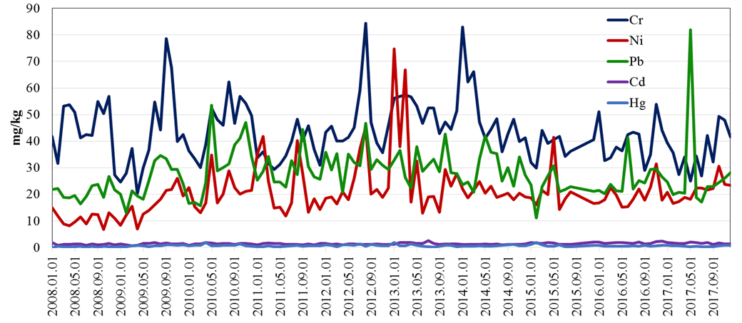

Fig. 1 Dynamics of some heavy metals concentration (mg/kg) in the sludge in 2008-2017

Zinc concentrations in the sludge have higher value than copper and sometimes can exceed the maximum available concentration for the sludge (Fig. 2). The decision to decrease zinc concentration at the primary its sources would have valuable positive impact on the final product of the sludge as fertilizer.

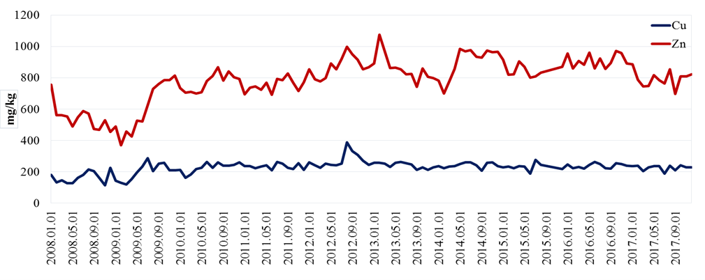

Fig. 2 Coper and zinc concentrations in the sludge dynamics in 2008-2017

The sludge content regarding such nutrients as nitrogen and phosphorus (Fig. 3) is important characteristic for the further application sludge as fertilizers for some kind of agricultural production, for animal’s feeding and environmental greening. High amount of the nutrients could enrich the quality of the soil and ensure good vegetation properties of the landscape where the substrates with sludge would be used.

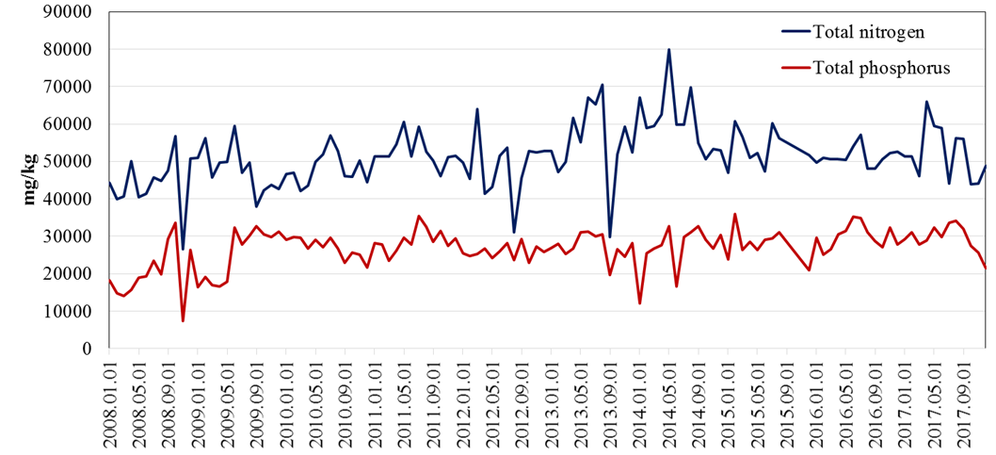

Fig. 3 Nutrients content in the wastewater sludge at the Klaipeda wastewater treatment plant

Table No. 4 Klaipeda WWTP sludge analysis (annual average values)

|  |  |  |  |  |  |  |  |  |  |  |  |  |
| --- | --- | --- | --- | --- | --- | --- | --- | --- | --- | --- | --- | --- |
| **Annual average sludge analysis data (SC “Klaipedos vanduo” WWTP)** | | | | | | | | | | | | |
| **Year** | **Cr** | **Cu** | **Ni** | **Zn** | **Pb** | **Cd** | **Hg** | **Ntotal** | **Ptotal** | **Dry Material** | **Organic material** | **pH** |
| **mg/kg** | | | | | | | | | **%** | |  |
| **2013** | 51,44 | 241,75 | 31,14 | 864,50 | 31,36 | 1,59 | 0,72 | 55233,8 | 27340,7 | 26,16 | 65,49 | 8,53 |
| **2014** | 50,06 | 241,92 | 20,56 | 901,25 | 29,56 | 1,19 | 0,63 | 60761,2 | 26734,1 | 42,16 | 65,82 | 8,00 |
| **2015** | 37,57 | 231,22 | 20,83 | 849,89 | 22,41 | 1,55 | 0,80 | 53635,7 | 27944,7 | 88,31 | 64,83 | 7,09 |
| **2016** | 40,16 | 239,00 | 19,78 | 910,08 | 25,50 | 1,80 | 0,53 | 51260,3 | 30026,2 | 87,46 | 63,10 | 7,10 |
| **2017** | 36,32 | 225,67 | 21,50 | 793,67 | 27,34 | 1,60 | 0,51 | 52173 | 29447 | 89,72 | 63,90 | 7,20 |
| **Sludge Categories (LAND 20-2005)** | **I** | **I** | **I** | **II** | **I** | **I,II** | **I** |  |  |  |  |  |

At the present time available sludge management methods for JSC “Klaipedos vanduo” WWTP would be:

* Disposal at composting sites. Currently dried sludge has been composting at JSC “Branda” composting site where compost is produced.
* Incinerate in Klaipeda waste incineration plant (JSC “Fortum Klaipeda”).
* Incinerate in cement plant as a fuel, e.g. in the SC “Akmenes cementas” in north-east part of Lithuania. It is planned in the end of 2019.
* Fertilize energetic forests.
* To design and construct sludge incineration plant in WWTP, using the heat power for sludge drying process.

1. **General remarks/conclusions in the national level**

* Sewage sludge treated as a waste in general, not as a product. Therefore, it leads to economic aspects, as e.g. WWTP companies needs to pay “gate fee” in the incineration plant, while producing sludge granules 11-12 MJ. According to the Ministry of Environment, opinion there is no standard for sludge fuel as a product. However, it is necessary to mention, that recently according to the new draft version of sludge compost’s legislation will have criteria for the certification as a product. In some cases, this will simplify sludge compost usage.
* Still there are companies discharging heavy metals to the city wastewater treatment’s plant in amount exceeding the MAC (Maximum Allowable Concentration). Industrial companies are penalized, but from economic point of view for companies better to pay penalty then to install an innovative and effective treatment/equipment on their site.
* Psychological barriers for sludge usage in agriculture. Even the companies preparing fertilization plans free, giving dried sludge free it is hard to find farmers/companies. Farmers afraid of the smell as well.
* Relatively high sludge compost insertion to the soil cost, as it is necessary to have equipment because sludge should be spread quickly. Fertilizers do not need this condition. Farmers prefer to choose mineral fertilizers that only need to be poured on the fields.
* High operational cost for sludge drying in the biggest cities. Recently, Lithuania has started to consider the possibility of advanced sludge recovery to the final product technological schemes, such as the sludge2energy system where sludge incineration heating energy will be used for sludge drying.

**Common Conclusion and recommendations:**

* Accumulated scientific evidence in general points to, that there are no adverse effects of using sludge from WWTP’s in agriculture
* The barriers to the use of sludge from WWTP’s as fertilizer in agriculture is mainly psykological
* Extremely strict National Limit Values can be a barrier (eg. Copper is Sweden), and could be rewieved
* Use of heavy metals and chemicals in different products should be further restricted (eg. Cadmium in artists paints)
* Restriction in use of plastic / non-biodegradable toilet-articles will be an advantage, so that plastic bits etc. do not so easily enter the sludge from the waste water.

The sludge composting process at Goleniow WWTP was interesting for the partners from Bornholm and Sweden, because it is very unusual in our countries.

We have discussed why, and the answer is apparently that the sludge in Denmark and Sweden is considered stable directly from the WWTP, and can be used directly in agriculture, which is economically optimal.

In Poland the legislation apparently is more demanding about stability, which is why the sludge must be composted before it is used in agriculture.

Advantages with composting: More stable product with less smell; potential infectious microorganisms is eliminated, and content of unwanted organic substances is reduces; the added straw and woodchips results in an increased carbon pool in the agriculture that receives the compost, and thus a positive climate effect.

Disadvantages with composting: Loss of nitrogen, as NH3, during composting; smell can be problematic as in Goleniow. The cost of facilities and labor in relation to composting.

In Rønne we have incentives to reduce the content of nutrients and organic matter in outlet, because this content is taxed:

Organic matter (BI5): 16,5 kr./kg (app. 2,2 euro/kg)

totN                           30,0 kr./kg (app. 4,0 euro/kg)

totP                          165,0 kr./kg (app. 22,0 euro/kg)

Sammanställning av slamkvalitetför alla partners så att man kan jämföra.

1. 28/07/2016 Order of the Ministry of Environment with latest amendment No. D1-517: <https://www.e-tar.lt/portal/lt/legalAct/TAR.3536A8337E8A/oOjEMmzJtx>
2. 14/03/2016 Order of the Ministry of Environment with the latest amendment No. D1-186 https://www.e-tar.lt/portal/legalAct.html?documentId=63c2f1c0ea7d11e58deaaf0783ebf65b
3. 28/07/2016 Order of the Ministry of Environment with latest amendment No. D1-517: <https://www.e-tar.lt/portal/lt/legalAct/TAR.3536A8337E8A/oOjEMmzJtx>
4. Draft order of the Ministry of Environment:

   <https://e-seimas.lrs.lt/portal/legalAct/lt/TAP/16d38e20c88c11e8a82fc67610e51066?jfwid=-w4wfq4b9z>
5. Source: Environmental Protection Agency: <http://vanduo.gamta.lt/files/Visuomen%C4%97s%20informavimo%20ataskaita_2019.pdf>