**STEP – National/local barriers to the use of sludge as fertilizer in agriculture**

The different countries in EU have different issues about the use of sludge in agriculture, and the national legislation is also different, although the same EU-directive regulate Limit Values of heavy metals in sludge from Waste Water Treatment Plants (WWTP) when used as fertilizer in agriculture (see table 1 and 3 below).

In the STEP project we have described the issues and barriers to the use of sludge in agriculture, from the perspective of each partner and the specific regulation their country.

Our common view on the subject, based on an ecological approach, can be explained in a few basic sentences:

Sludge from WWTP’s:

* is a valuable biomass, and as much as possible of the nutrients in the treated waste water should be collected in the sludge / as little as possible of nutrients, organic matter and chemical in the treated waste water should pass onto the recipients.
* should, if possible, be used as fertilizer in agriculture, so the valuable nutrients are recycled, and the carbon in the sludge is build into the soil, instead of quickly released as CO2.
* should, if possible, be digested to produce biogas / energy, thus replacing fossil fuels

In the next pages the STEP-partners describe the local/national barriers to the use of sludge in agriculture, from their points of view and experience:

1. DENMARK - Bornholm

**Heavy metals:**

Cadmium – is usually the heavy metal in sludge that might come closest to, or surpass, the limit value in DK. ThIs is not surprising when we take a look at the table comparing Limit Values: Denmark has one of the lowest limits for Cadmium in EU: 0,8 mg/kg DM (or 100 mg/kg P), where the directive operates with 20-40 mg/kg DM

One of the WWTP’s on Bornholm (Boderne) sometimes come close to, and accationally surpass, the Danish limit value of Cadmium. It is possible that the large amount of excess water this WWP receives contributes to this situation.

The low Danish Limit value for Cadmium is generally not a barrier to agricultural use of sludge in Denmark or Bornholm, and it gives us a natural focus on industrial waste water permissions, where the allowed concentration of Cadmium in waste water is usually low.

Eg: Mass balance calculations in relation to the Cadmium input to Rønne WWTP, resulted in an allowed concentration of max 0,2 microgram/l in the condensed water from the power plant in Rønne, when the main boiler was rebuild from burning coal to woodchips in 2016. In a permit from 2018 the same maximum concentration is allowed for a new facility on Rønne harbor, to recieve wastewater from Cruise Ships.

**Organics**

Denmark and Sweden are some of the few countries in EU where the national legislation has Limit Values for groups of organic compounds:

LAS: Linear Alkylbenzene Sulphonates are the most extensive used anionic detergents in cleansing agents. Despite the high separation efficiency in sewage treatment plants LAS outlet concentrations are in the range 0,02 – 0,9 mg LAS l-1 (Berna et al. 1989; Berna et al. 1991). LAS are only slowly degradable in anoxic environments and may become concentrated in marine environment. In estuaries and near-shore marine waters, LAS has been found in concentrations that affect normal growth and development of marine

organisms (Christensen et al. 1998; Hansen et al. 1997; Kimerle 1989). LAS are now on the Danish Environmental Protection Agency’s list of undesirable substances in the group of non-anaerobic degradable substances.

PAH: Polycyclic aromatic hydrocarbons are of interest because of their potential toxic and carcinogenic properties. Due to their low water solubility and their high affinity for organic matter, PAHs are easily concentrated in sewage sludge. Under methanogenic conditions, PAH removal about 50% has been demonstrated; under aerobic conditions, the aerated process enhanced PAH removal up to 90%. (E. Trably · D. Patureau · J.-P. Delgenes, 2005)

In one of the WWP’s on Bornholm the limit value of PAH has a few times been surpassed. This problem has been solved by composting.

NPE: NPE are a group of nonionic detergents which are present in many laundry and cleaning agents. Consequently, research regarding mineralisation of theses compounds became important to the discussion

about whether the agricultural sector could continue as a receiver of sludge in the future.

#### DEHP (diethylhexylphthalat) belongs to a group of phthalate esters which is used in large amounts as

softner or plasticizer in Polyvinyl chloride (PVC), a hard, brittle plastic, only when softeners are added that it becomes softer and pliable and can be made into floors and other products. In soft PVC floorings these are not securely bound, but can evaporate or wash off from the products or escape into the room as a result of wear.

DEHP in sludge: Most of the DEHP in waste water is decomposed in the WWTP’s. But a large amount is also adsorped in the sludge. In 1992 it was estimated that 7 tons DEHP per year was retained in sludge from Danish WWTP’s.

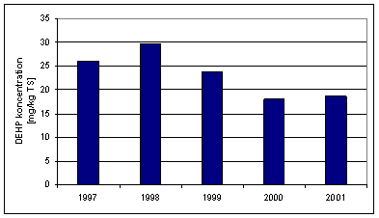

Koncentration of DEHP in sludge from Danish WWTPs - 1997 til 2001. Data from the Danish EPA.

**“Psykological barriers”**

“The Arla directive”: The mayor Danish diary-company, Arla, don’t allow their milk suppliers to use sludge on fields where their cows feed.

**Sludge from Septic tanks**

On Bornholm the sludge from septic tanks (app. 5000) is composted to reduce the content of organic compounds, eg. LAS, below the limit values. The sludge Is composted with straw cut in bits, and then mixed with burned lime, before it is used as fertilizer in agriculture.

This is a cheep, energy-effective way to handle sludge from septic tanks. A problem with this is misdisposed inorganic material eg. Plastic bits, in the sludge, that is an unwanted (mostly visual) pollution of the fields.

A comparison between different practical methods of handling sludge from septic tanks is done in the STEP-project (see: xxxxxx)

EU-report: **Disposal and recycling routes for sewage sludge,** Part 2 - Regulatory report October 2001:



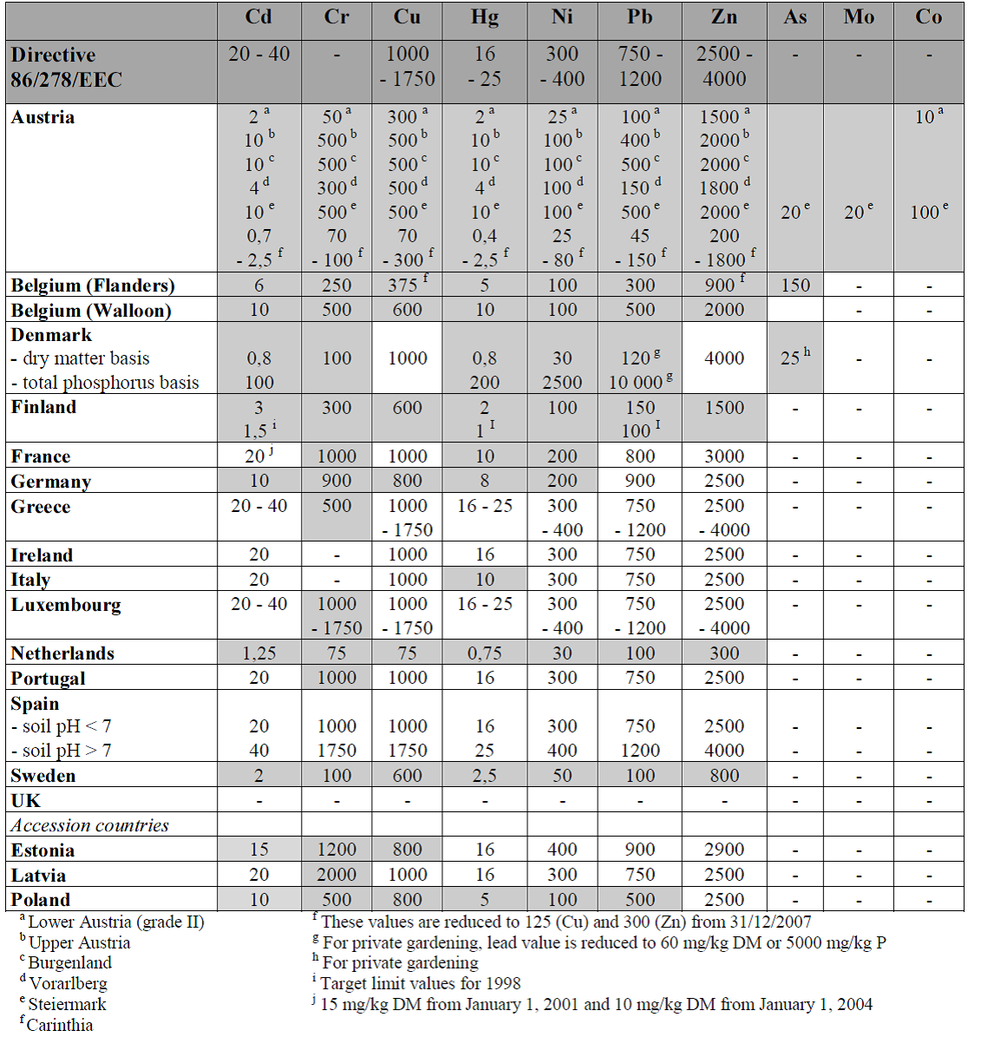

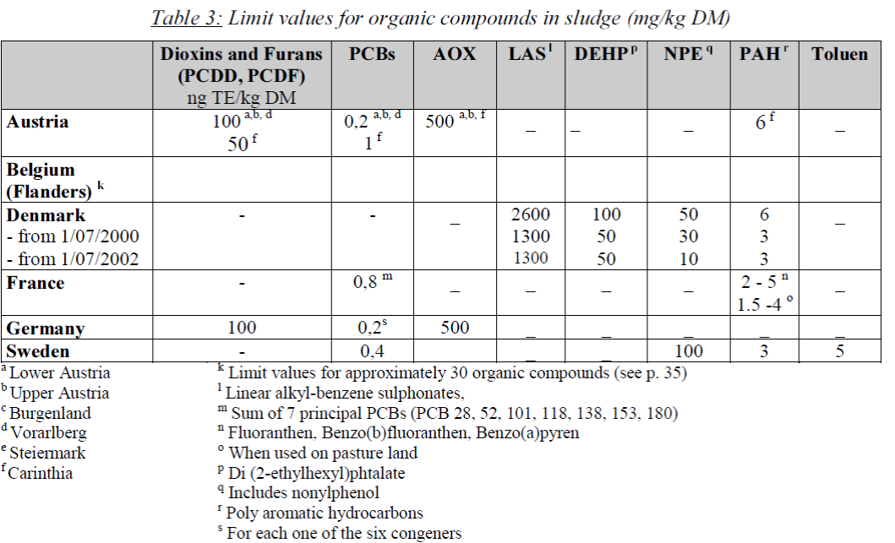

**Common Conclusion and recommendations:**

* Accumulated scientific evidence in general points to, that there are no adverse effects of using sludge from WWTP’s in agriculture
* The barriers to the use of sludge from WWTP’s as fertilizer in agriculture is mainly psykological
* Extremely strict National Limit Values can be a barrier (eg. Copper is Sweden), and could be rewieved
* Use of heavy metals and chemicals in different products should be further restricted (eg. Cadmium in artists paints)
* Restriction in use of plastic / non-biodegradable toilet-articles will be an advantage, so that plastic bits etc. do not so easily enter the sludge from the waste water.